Please refer below step for solving this error.
ERROR::

- When you getting below error so how to resolve this case

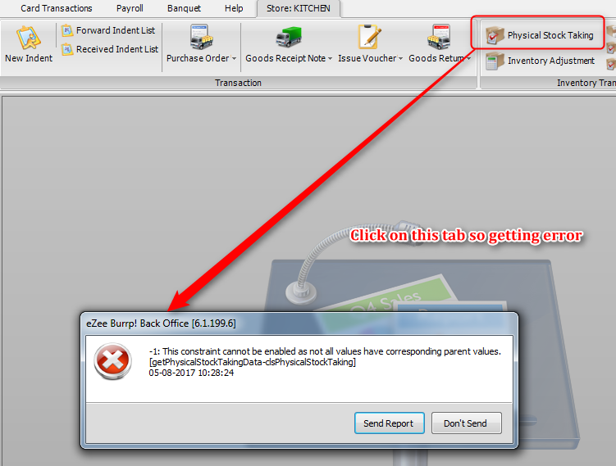

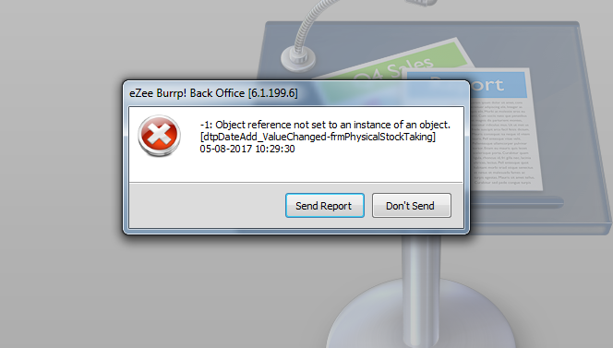

SOLUTAION::

- Restore Database on NextGen.

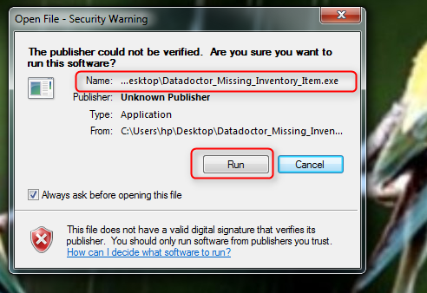

- Run attached tool so you will get inactive Item list for a Particular store.

https://ezeenextgen.s3.amazonaws.com/download/eZeePOSTool/Datadoctor_Missing_Inventory_Item.exe

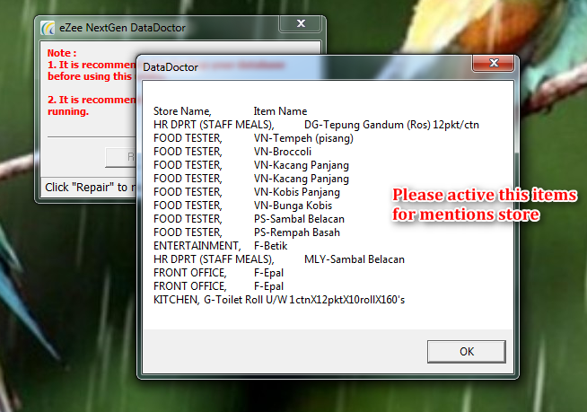

3.Active all Item for Particular store and resolved this case.

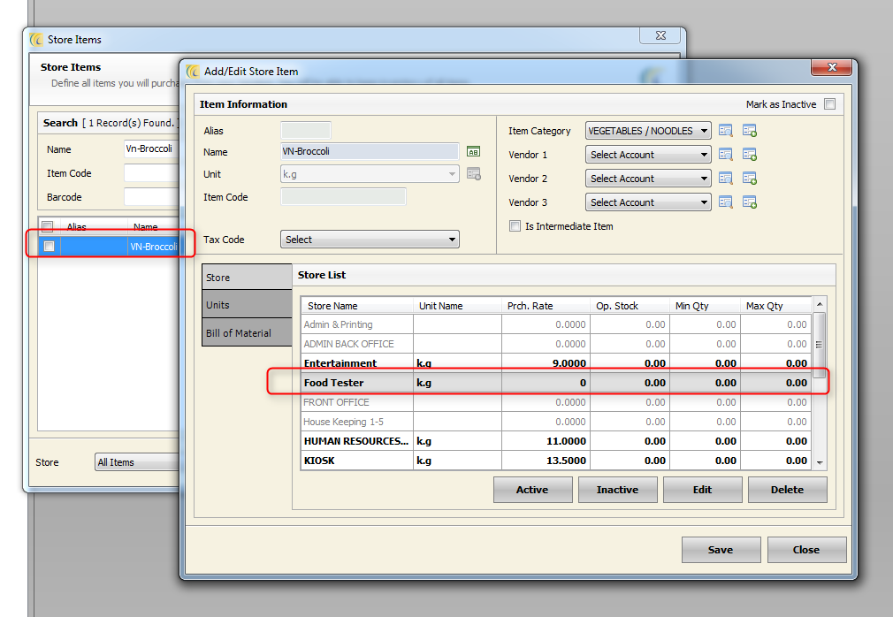

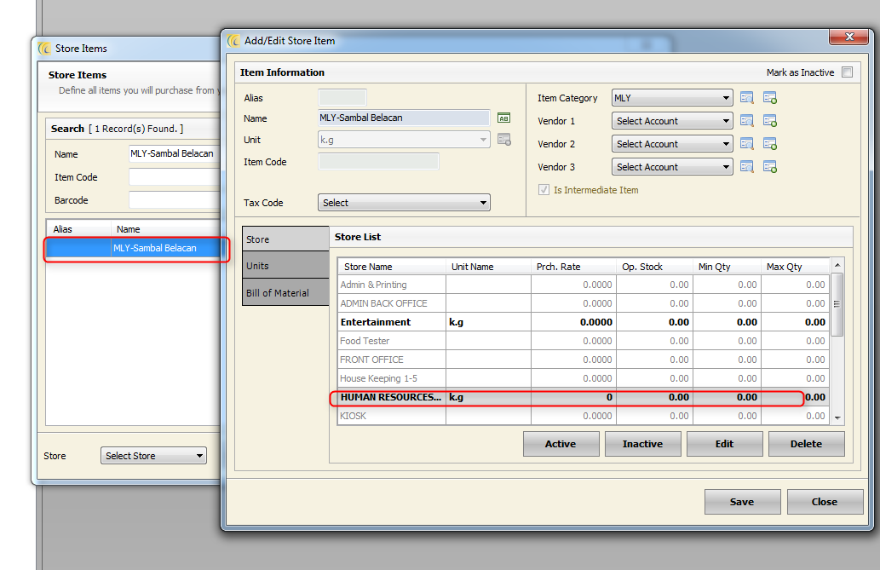
4.Check store so it is working fine.
