Author: Dechen
Introduction:
This document is created with the intention that integration between eZee Frontdesk with any accounting software is implicit and exciting.
Sample accounting software used for this document is AutoCount, one of the most popularly used accounting software in Malaysia after the government started applying GST since 1st of April 2015.
eZee AutoCount interface is an application that links eZee Fontdesk to AutoCount accounting software.
For configuration, account mapping and posting, please refer to our Manual for eZee Auto count.
Key topics:
- Guest ledger
- Advance Deposit Transfer
- Folio Transfer
- City Ledger posting

- Guest Ledger :

Before we start the integration it is very important for us to understand Guest Ledger, how it works and what are the reports that we can refer to in eZee Frontdesk to view details of the Guest Ledger.

“Guest ledger (or front office ledger or transient ledger) is the collection of all accounts receivable for currently registered guests. It can also be defined as the collection of all guest folios. A folio (billing receipt) is the account of an individual guest who is currently registered” ~by Wikipedia

Guest ledger contains almost all the frontdesk transaction; Revenue, payment collection, deposit, refund except for those passer-by charges (Misc. Sales) as it is a Cash on delivery and its entry into the account software is straight forward (Credit it’s Revenue account and debit the Cash/Bank account)

We take a Simple example:

Dechen Tshomo check-ins on 10th September 2016 and checks-out on 15th September 2016. The room Tariff is 106 (inclusive of 6 % GST) on each day. On 10th of September, Dechen makes a payment of RM 530 with her Master Card, and RM 100 cash for Security Deposit. On her check out date i.e. 15th of September, she is refunded the deposit of RM 100

  - On the 10th September

At eZee Frontdesk:

Folio Summary for this Guest will look like: 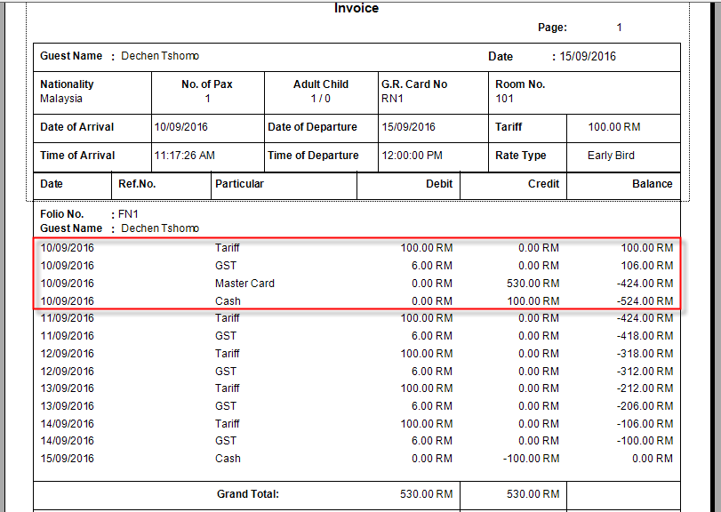You can see from the folio summary that on 10th September, the closing balance of this guest is (524).

Let us take a look at our “Daily Summary Report”, Guest ledger block:

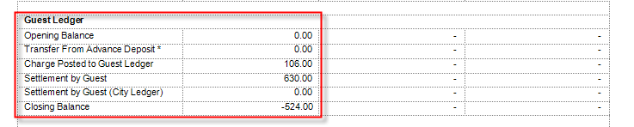

Charges posted to the guest ledger is 106, Settlement by Guest is 630 (530+100)
Closing balance= 106-630 = (524)

For detail, we look at “Guest Ledger Report”:

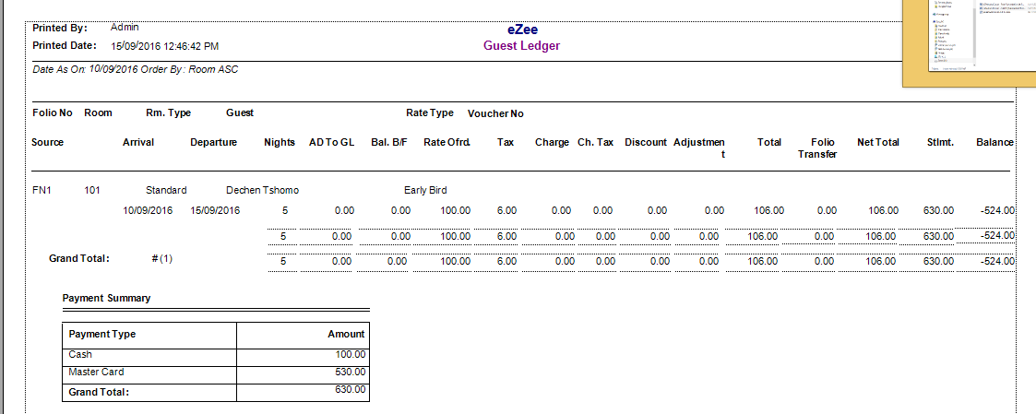
Bal.B/F = 0
Total Charges = 106
Total Guest Settlement = 630
Balance= 106-630 = (524)

eZee AutoCount:

There are four transaction that we have to post to AutoCount
Room tariff = 100, Tax= 6, MasterCard= 530, Cash =100

We have to transfer this transaction from two places:
Sales:

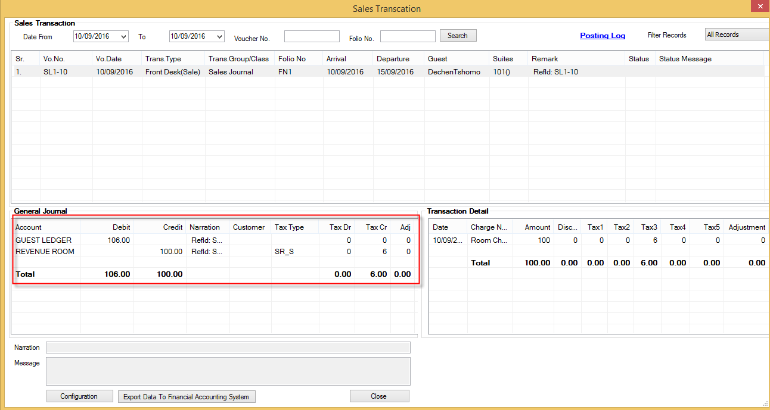
Credit REVENUE ROOM 100
Credit Tax (GST Output Account) 6
Debit GUEST LEDGER 106
Note: Vo.No has prefix SL

Receipt Posting:
Posting Master Card payment RM 530
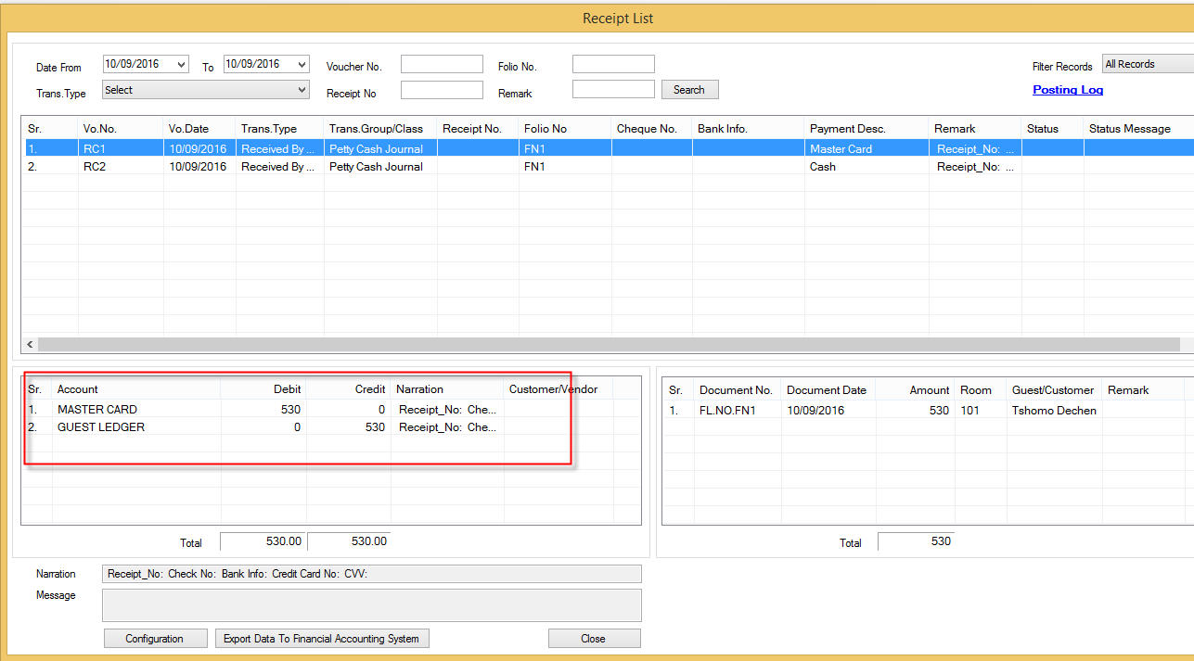
Credit GUEST LEDGER 530
Debit MASTER CARD 530
Note: Vo.No. has prefix RC
Posting deposit of RM 100 paid by cash:
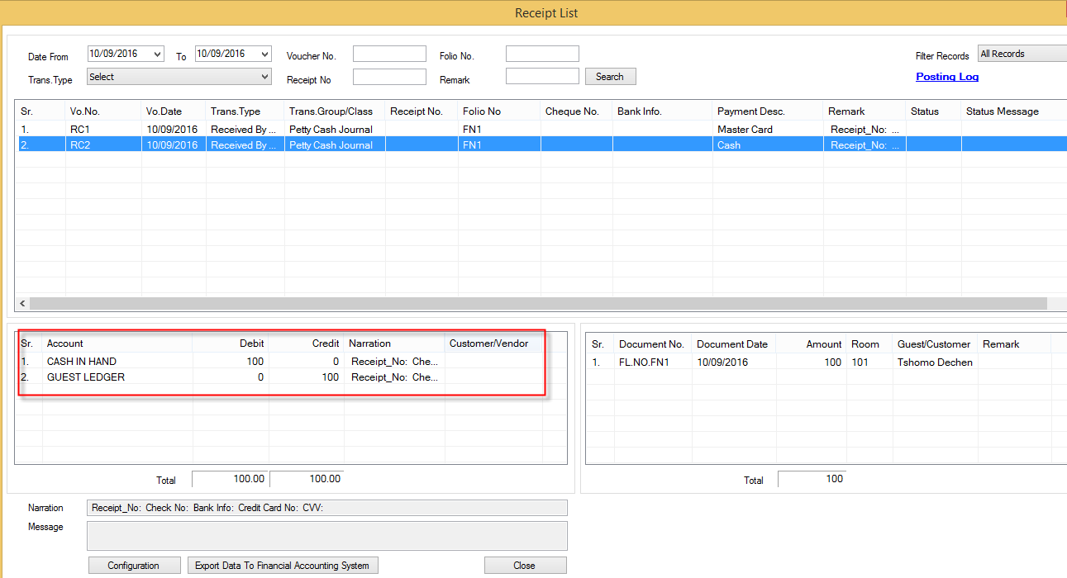
Credit GUEST LEDGER 100
Debit CASH IN HAND 100

Following are the double entries for the all 4 transaction to be posted to AutoCount:

Debit GUEST LEDGER 106
Credit REVENUE ROOM 100
Credit Tax (GST Output Account) 6

Credit GUEST LEDGER 530
Debit MASTER CARD 530

Credit GUEST LEDGER 100
Debit CASH IN HAND 100
GUEST LEGDER |  |  | REVNEU ROOM |  |  | GST OUTPUT |  |  | Master Card |  |  | Cash
Dr | Cr |  | Dr | Cr |  | Dr | Cr |  | Dr | Cr |  | Dr | Cr
10 |  |  |  | 100 |  |  | 6 |  | 530 |  |  | 100
6
 | 530
 | 100
Now on the AutoCount Accounting Software after we have done the posting:

We check the Journal entry:

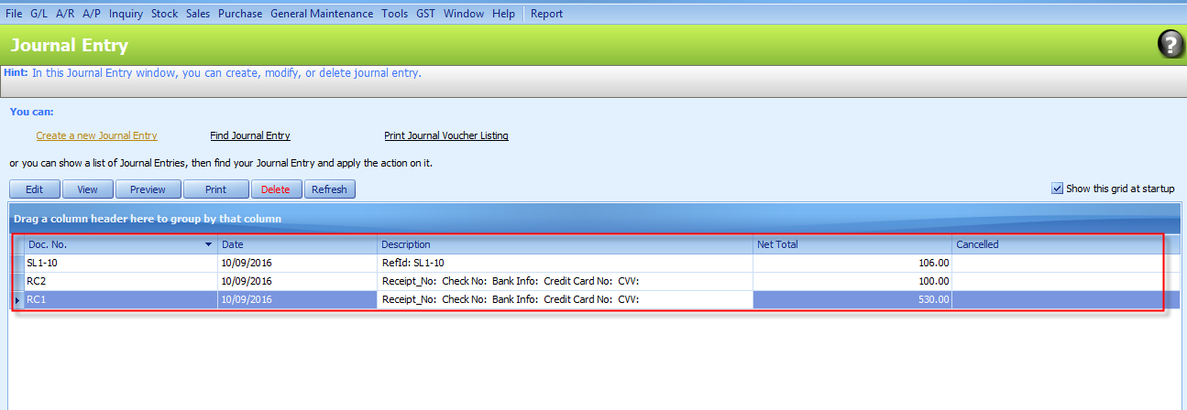

All the transaction will be posted as Journal entry into AutoCount. They have their own unique Doc No. The one that starts “SL” is for sales and that starts with “RC” is for settlement. Likewise, Doc No will have different prefix depending on the nature of their transaction.

Let’s now check the Ledger Report and filter for Guest Ledger account:

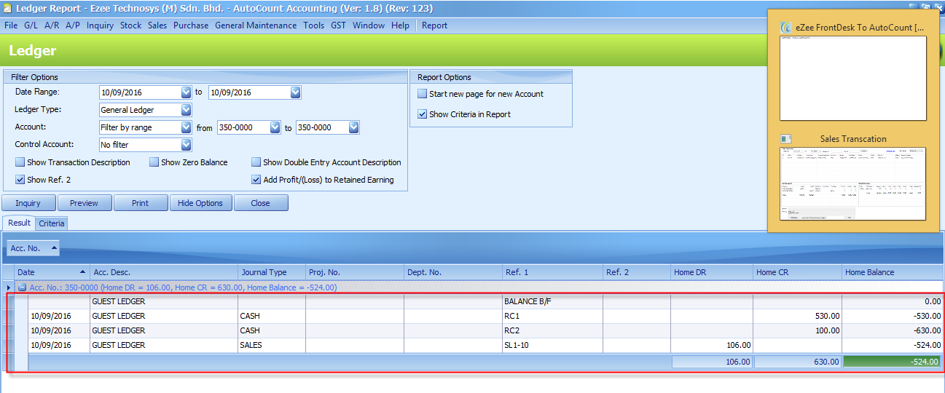
You can see that Guest Ledger Balance is (524) in AutoCount is exactly the same as that of folio Summary, Daily Summary Report and Guest Ledger at the Front desk.

  - On 11th September

At eZee Frontdesk:

Daily Summary Report: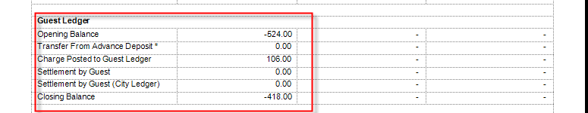

Opening balance is (524), Charges posted to the guest ledger is 106, Settlement by Guest is Closing balance= (524) + 106 + 0 = (418)

Guest Ledger Report:

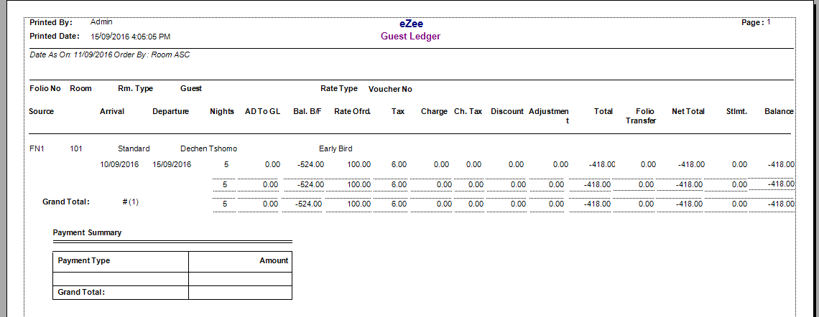

Bal.B/F = (524
Total Charges = 106
Total Guest Settlement = 0
Balance= (524) +106-0 = (418)

On the 11th September, there is a Balance brought forward from 10th September.

As we can see that Dechen paid RM 630 including the deposit but the Revenue is posted only on daily basis. However, on 10th September the tariff is RM 106 only that’s why there is a balance brought forward on 11th September.

At eZee AutoCount:

We only need to do the sales posting as there is no payment made on that day: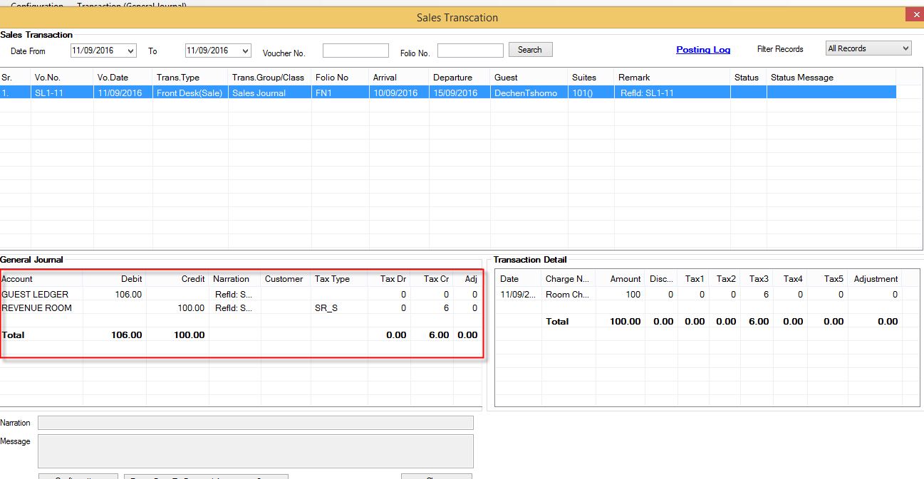

Debit GUEST LEDGER 106
Credit REVENUE ROOM 100
Credit Tax (GST Output Account) 6

At AutoCount:

Ledger Report and filter for Guest Ledger account:

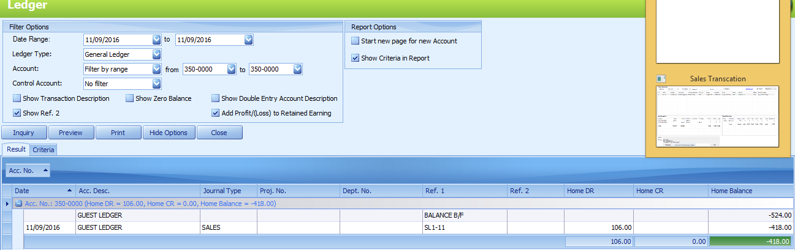

You can see that Guest Ledger has a Balance B/F of 524 and the balance for 11th September is (418) in AutoCount, which is exactly the same as that of Daily Summary Report and Guest Ledger at the eZee Frontdesk.

  - 12, 13 and 14th of September will follow the same as that of 11th September, taking the balance B/F from its previous day.

  - 15th September ( Check-Out Day)

On 15th September Dechen checks out, and hotel pays back (refund) RM 100 to her and check’s her out from eZee Frontdesk.

At the eZee Frontdesk:

Daily Summary report:

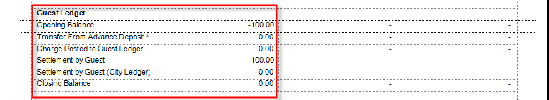

Charges posted to the guest ledger is 0, Settlement by Guest is (100)
Closing balance= 100-(100) = 0

Guest Ledger Report: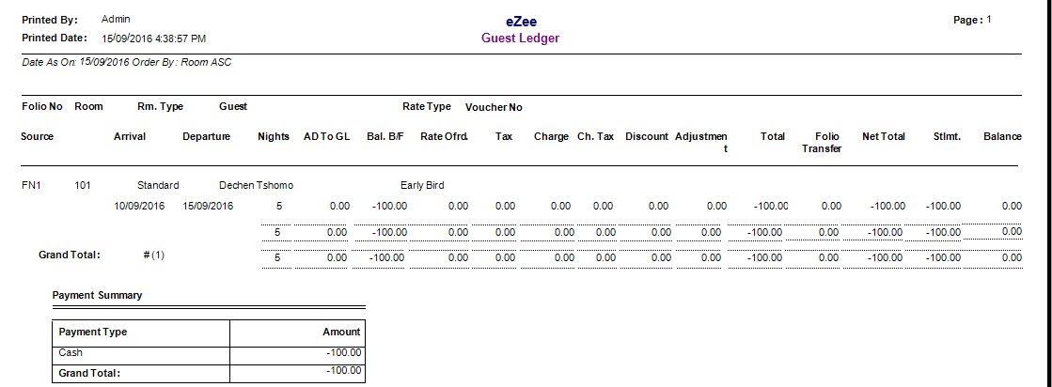

Bal.B/F = (100)
Total Charges = 0
Total Guest Settlement = (100)
Balance= (100) +0-(100) = 0

On the 15th September there is a Balance brought forward of only RM 100.
She paid for 5 days, and on 15th September, her fifth day is complete, therefore the balance B/F is only the Deposit of RM 100 that she paid on 11th September.

As it’s her check-out day and she didn’t incur any extra charges, the total charges is 0.

At eZee AutoCount:

We only need to do Payment (Refund) posting as there is no charges incurred.
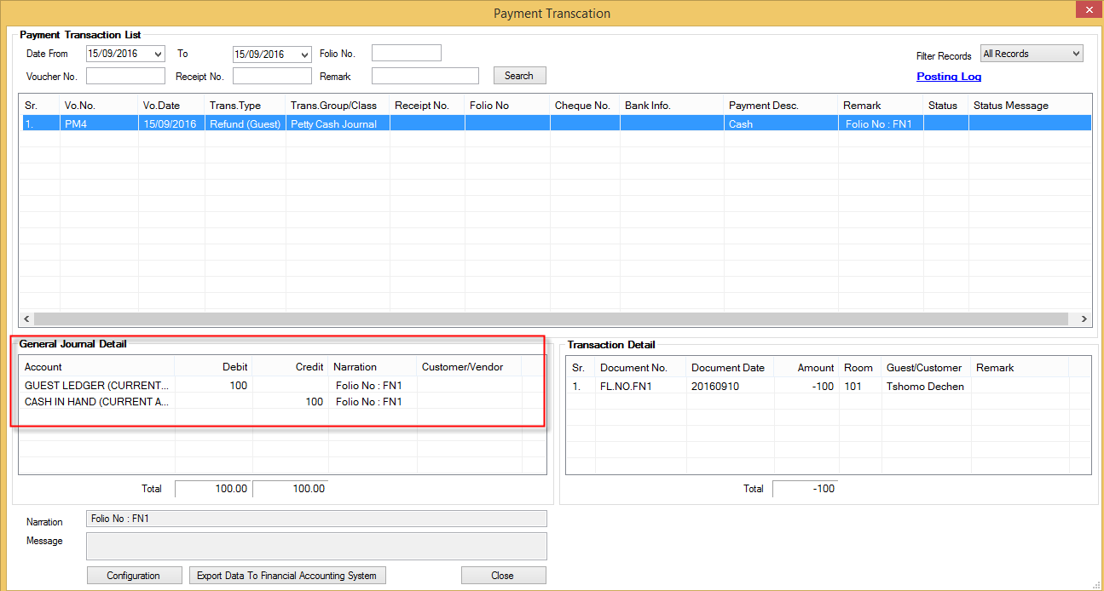
Credit CASH IN HAND 100
Debit GUEST LEDGER 100
Note: Vo.No prefix is PM, for refund the prefix is PM

At AutoCount:

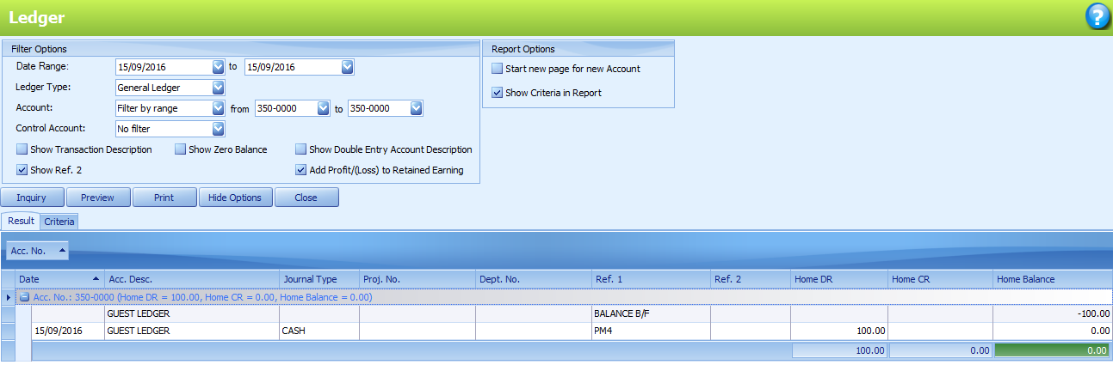
On the 15th September, the Guest ledger balance on AutoCOunt is same as that of Daily summary report and Guest ledger report on 15th September on eZee Frontdesk.

Now let’s see the Ledger report on Auto Count from 10th to 15th of September :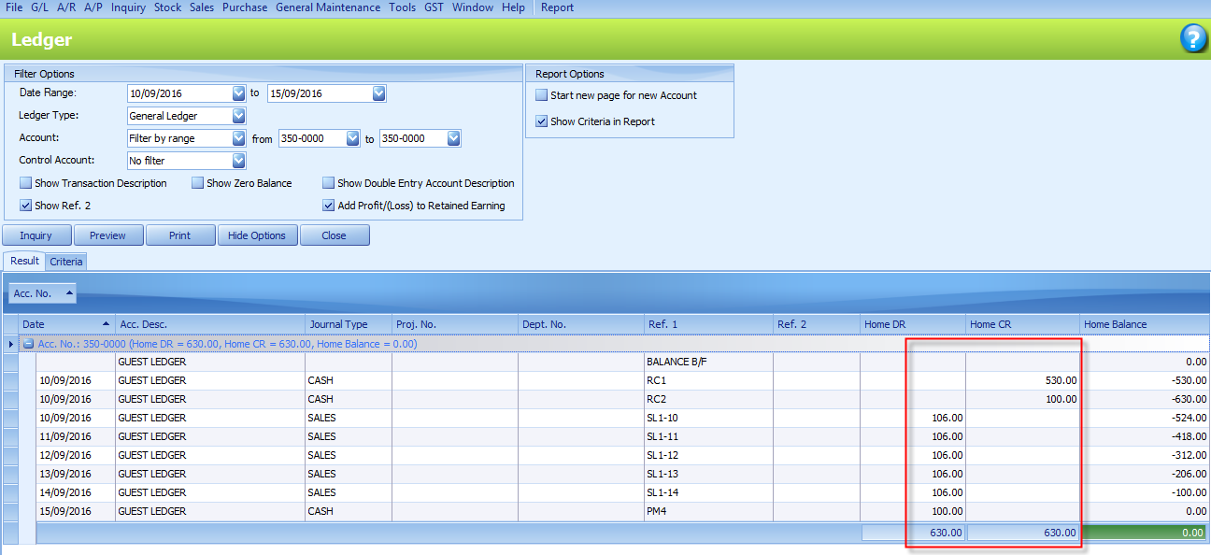

You can see that it is similar to that of Folio summary show in point 1.1.

We can conclude that all the transaction is being successfully posted from eZee Frontdesk to AutoCount and GUEST LEDGER is the one that takes care of it.

It is must that the Guest Ledger balance matches between eZee Frontdesk and AutoCount.

- Advance Deposit Ledger

Any Payment made by the Guest before arriving at the hotel by means like cheque, credit card, online payment etc. is known as Advance deposit.

This amount is not transferred to the Guest ledger until the Guest arrives at the hotel.

A ledger called Advance Deposit ledger is maintained to record all the advance deposit made by the guest.

Advance Deposit transfer from Advance Deposit ledger to guest ledger happens only when the guest checks-in.

Take an example:

On 13th September Nicole Lim makes a room reservation at Hotel A for two nights stay, the room rent is RM. 106 per day. She will check-in on 26th of September and check out on 28th of September.

On reservation date she makes an advance payment for first night which is RM. 106 by Master Card. She checks in on the 26th and makes the balance payment of RM.106 by cash.

  - On the 13th of September

At eZee Frontdesk
On 13th Nicole pays a payment of RM.106 against reservation RES1

Advance deposit Ledger:
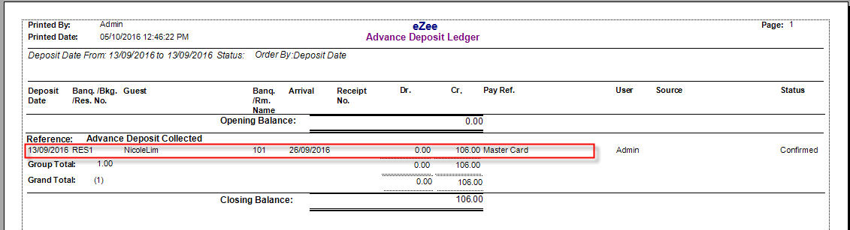
Opening Balance: 0
Advance deposit: 106
Closing balance: 106

Daily summary Report
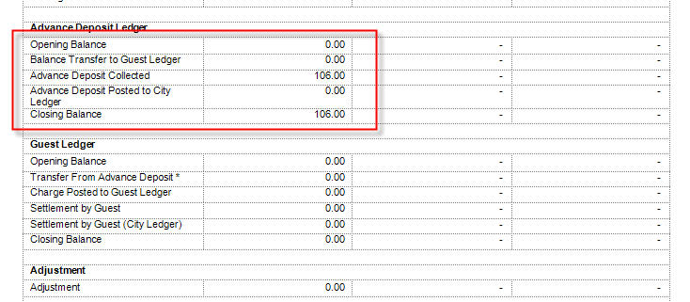
Opening Balance: 0
Advance deposit: 106
Closing balance: 106

At eZee Autocount

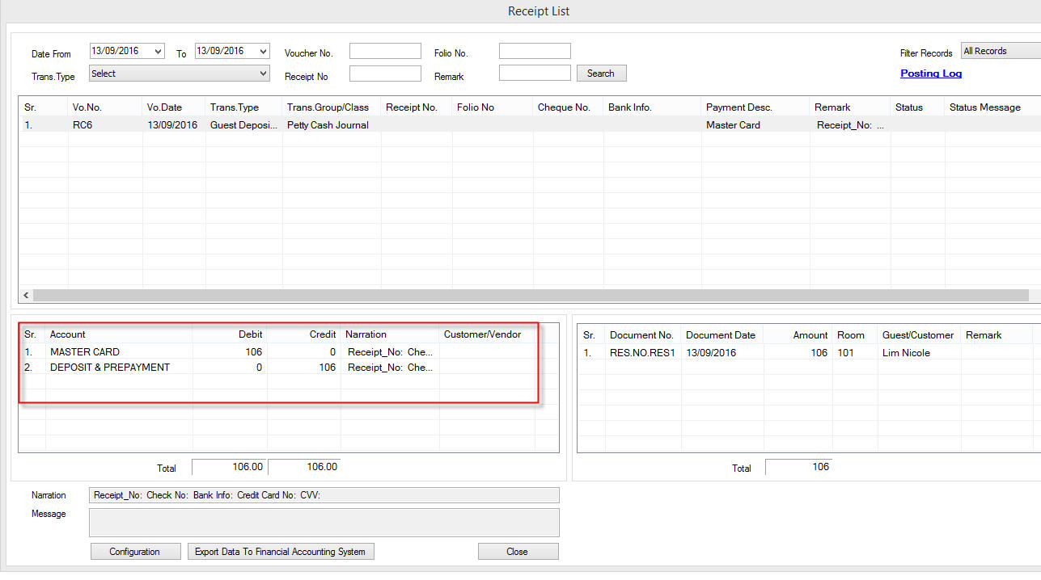

Cr. DEPOSIT & PREPAYMENT
Dr. MASTER CARD

At AutoCount

DEPOSIT & PREPAYMENT ledger
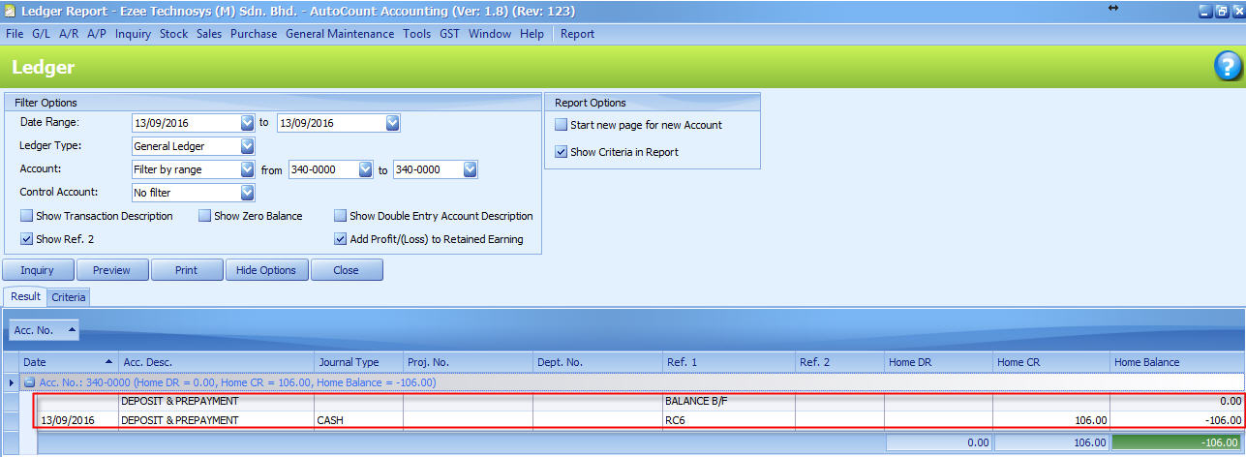

On 13th of September, the balance in DEPOSIT & PREPAYMENT is as same as that of advance deposit ledger.

  - On 26th of September

At the eZee Frontdesk
Nicole checks into hotel and pays the balance.

Advance Deposit Ledger
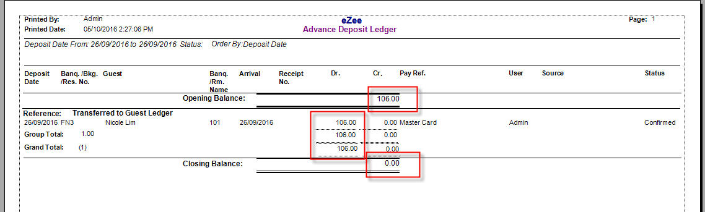

Opening balance= 106
Deposit transfer = 106
Closing balance = 0

Daily Summary Report
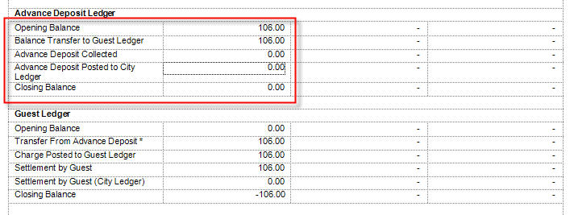
Opening balance = 106
Bana lance transferred to guest ledger = 106
Closing balance = 0

Guest Ledger 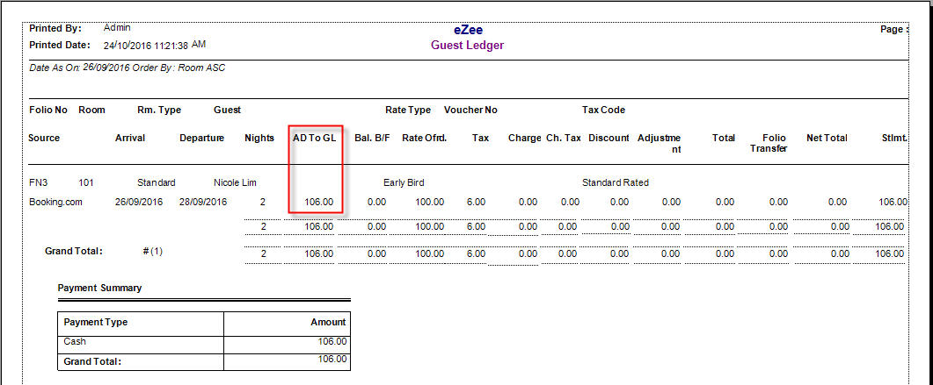
AD To GL = 106
ADtoGL is advance deposit transferred to guest ledger

At eZee Autocount

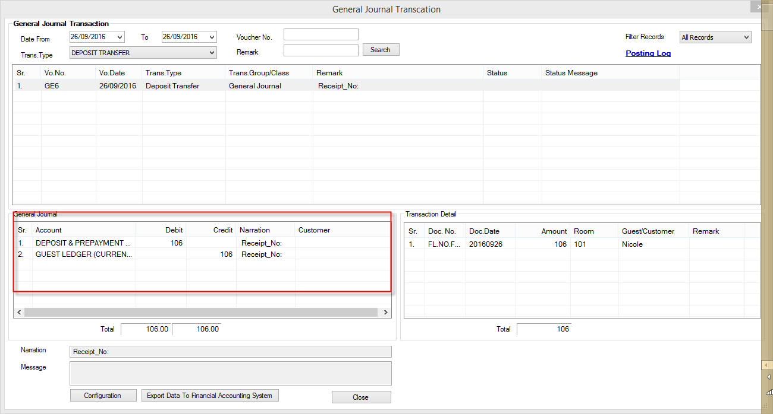

Cr. GUEST LEDGER 106
Dr. DEPOSIT & PREPAYMENT 106

At AutoCount:

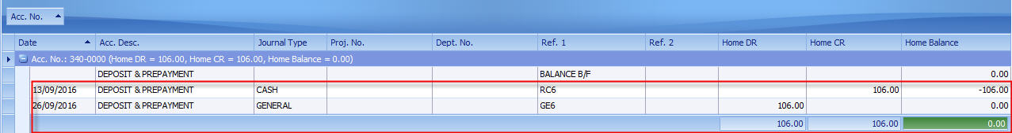

You can see from the above example that the Advance deposit ledger in eZee and DEPOSIT & PREPAYMENT is tallied.

It is must that this two Ledger is tallied all the time

- Folio Transfer

As stated by its name, Folio transfer is transferring charges from one folio to another, typically, when one guest wants to pay for another guest staying in different rooms.

Folio transfer is also used when a guest wants to post restaurant bills to their room.

Take an example:

Ms. Lau Vivian is staying in room 101, her total charges is RM.53 and Leanne Tan is staying in room 102, her total charges is RM. 106. A folio transfer of RM. 53 is done from 101 to 102.
Therefore, Vivian’s room is settled but Leanne’s Total charges become 106+53= 159, which settles by cash.

At the eZee Frontdesk:
Daily Summary Report 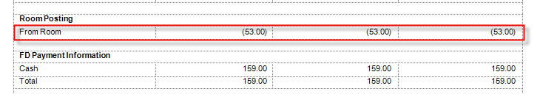

From Room = 53
If there was any posting made from POS then it would have shown as “From POS” and “From Banquet” if it is from Banquet

Daily summary Guest ledger Block 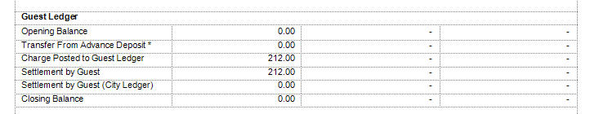
Charges Posted = 212 = 106 (Leanne’s total charges) + 53 (Vivian’s total charges) + 53 (folio transfer)
Settlement by guest = 212 = 159 (cash payment made by Leanne) + 53 (folio transfer)

At eZee Autocount 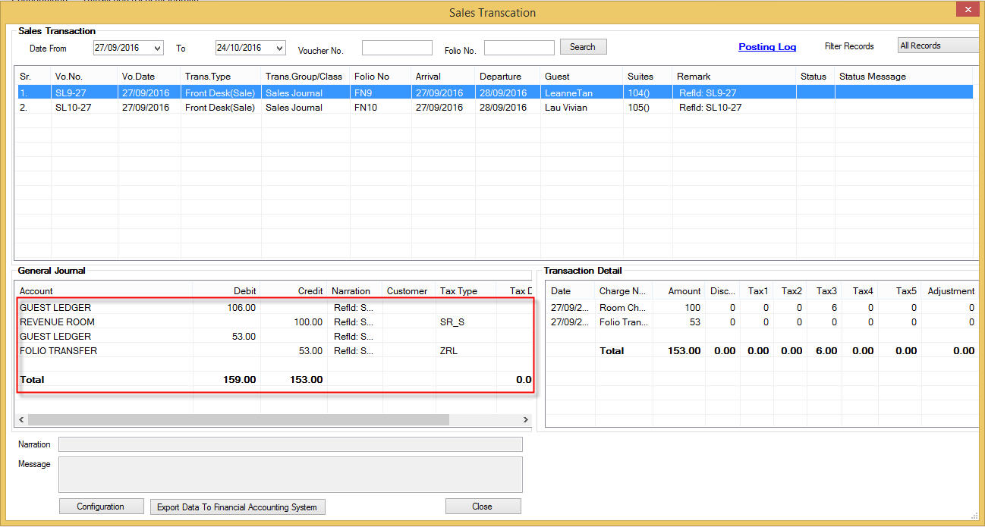From Leanne’s room

Cr. REVENUE ROOM 100
Cr. GST OUTPUT 6
Dr. GUEST LEDGER 106
Cr. FOLIO TRANSFER 53
Dr. GUEST LEDGER 53

From Vivian’s room
Cr. REVENUE ROOM 100
Cr. GST OUTPUT 6
Dr. GUEST LEDGER 106

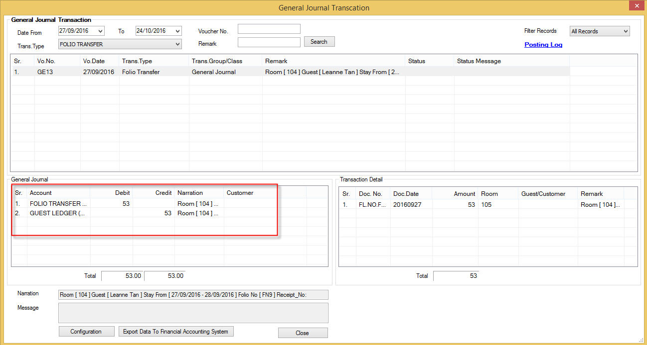
Cr. GUEST LEDGER 53
DR. FOLIO TRANSFER
At AutoCount
Folio Transfer 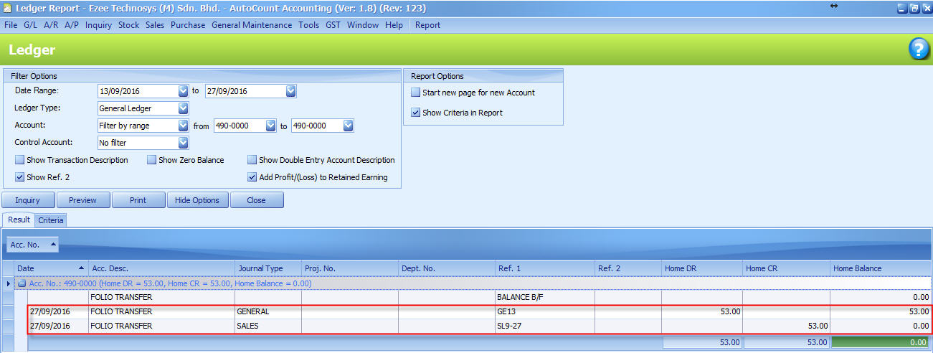

Guest Ledger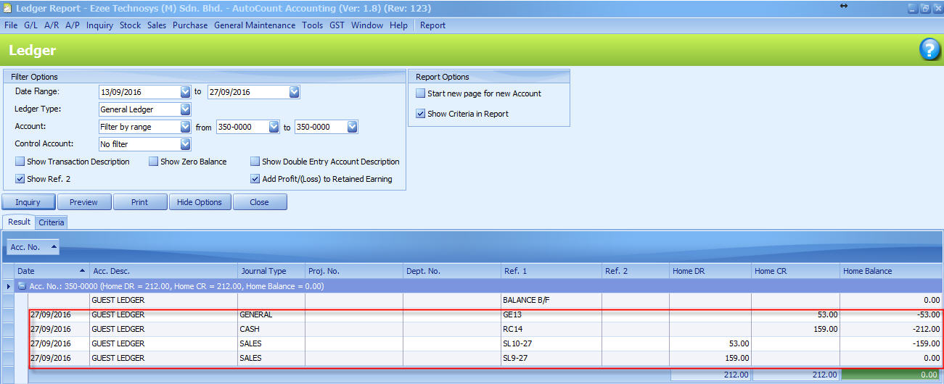

The folio transfer posting should match the amount in Room posting block at the frontdesk Daily summary report.

Make sure that the folio transfer balance in AutoCount is always “Zero”

- City Ledger
“In hotel accounting, the city ledger is the collection of accounts belonging to non-registered guests. This is distinct from the transient ledger (or front-office ledger, or guest ledger), which is the collection of accounts receivable for guests who are currently registered.

Included in the city ledger are accounts belonging to various companies that utilize the hotel for meeting space and for lodging travelling executives. Instead of billing separately for each individual service that the hotel provides, the charges are accumulated in the company's city ledger account. The hotel then periodically sends the bill to the company” ~ Wikipedia

In eZee, the city ledger not only handles the billing to companies but also provides records of paid/unpaid bills, companies aging report and lot more.

Integration for city ledger can be done in two ways:
- Method 1: By posting all the city ledger entries under a General Ledger at AutoCount
- Method 2: By posting city ledger entries for separate companies to individual debtors account in AutoCount (AR debtors)

Take an example:

“Jackson Tay from Company ABC Sdn Bhd stays at the hotel on 1st of October, the room tariff is RM. 106 inclusive of GST. Upon his check-out on 2nd of October his bills is posted to City ledger “ABC Sdn Bhd”.
On 1st of Nov ABC Sdn Bhd clears the bill for Jackson Tay by Baking-in the RM.106 to Company May Bank Account. “

  - On 1st of October
Room Sales of RM.106 is posted to Auto Count. Which makes the guest ledger closing balance 106 at Auto Count and eZee Frontdesk.

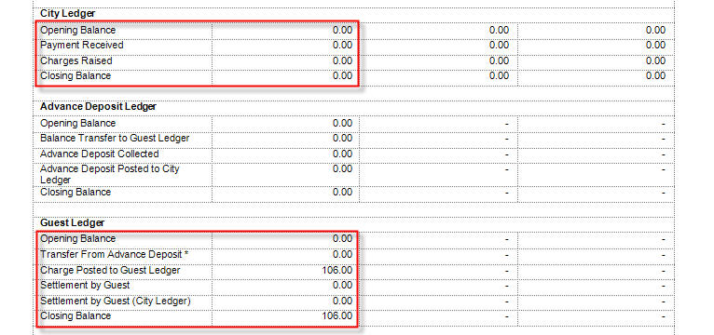
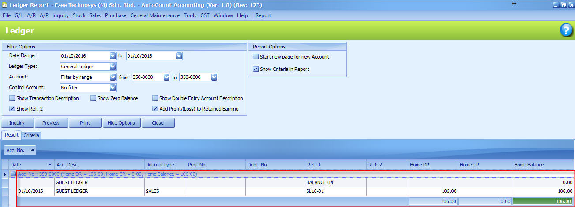

  - On 2nd of October

At eZee Frontdesk

Daily Summary Report
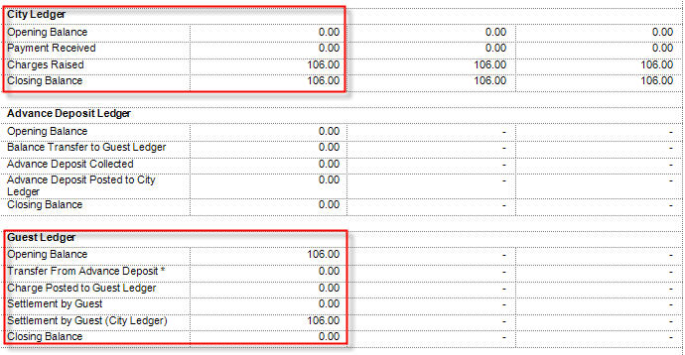
Under Guest Ledger, you can see “Settlement by Guest (City Ledger)” is 106 which makes the Guest ledger closing balance 0

Under City Ledger “Charges Raised” is 106 which makes the closing balance is 106

At eZeeAutocount

Method 1: Posting the city ledger entry to General Ledger
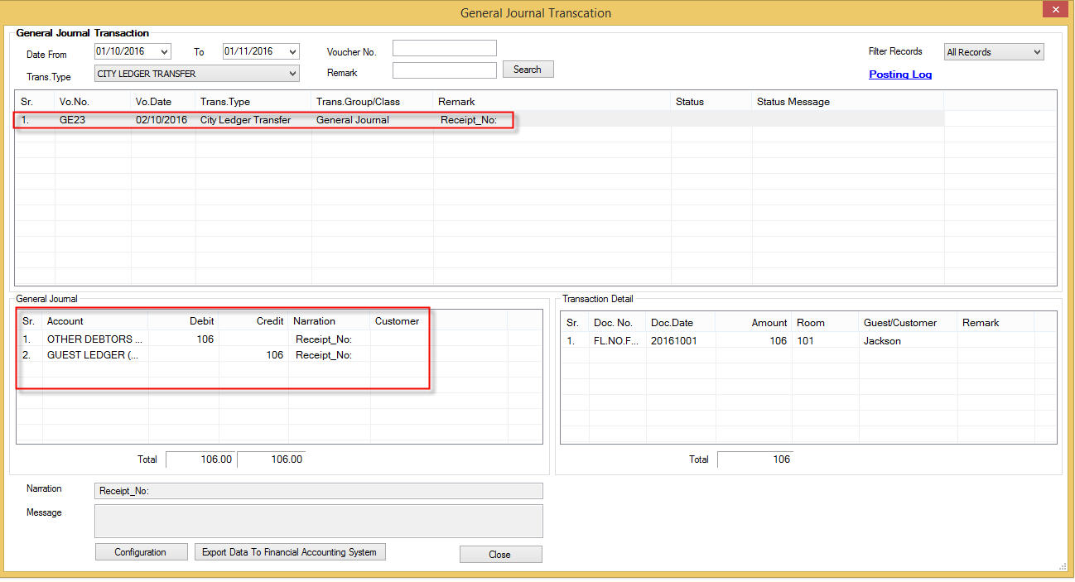
The entry is posted to a general ledger account called “OTHER DEBTORS” in auto count
Cr. GUEST LEDGER 106
Dr. OTHER DEBTORS 106

Method 2:

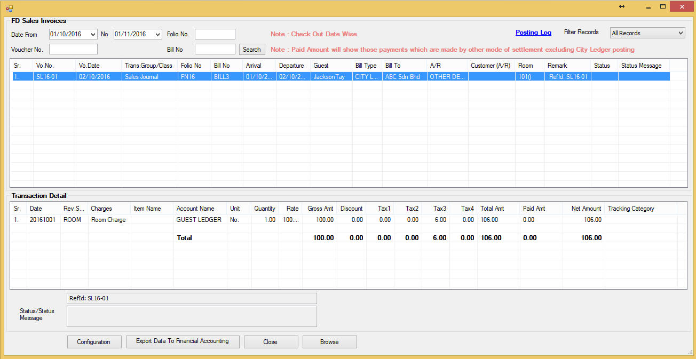
The entry is posted to AR Debtors account called “ABC Sdn Bhd” in AutoCount
Cr. Guest Ledger 106
Dr. ABC Sdn Bhd 106

At AutoCount

Method 1:
Other Debtors
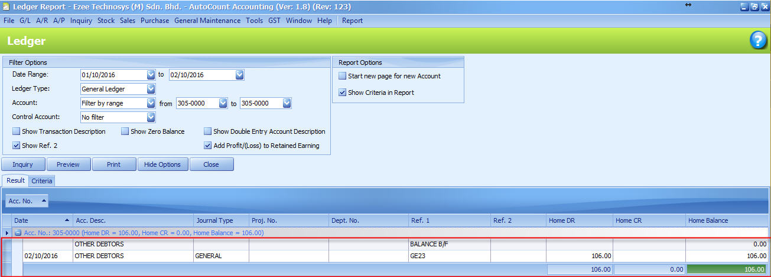

Closing balance of the OTHER DEBTORS account is as same as that of City Ledger closing balance on the Daily Summary Report at the eZee Frontdesk.

Method 2:
AR Debtors
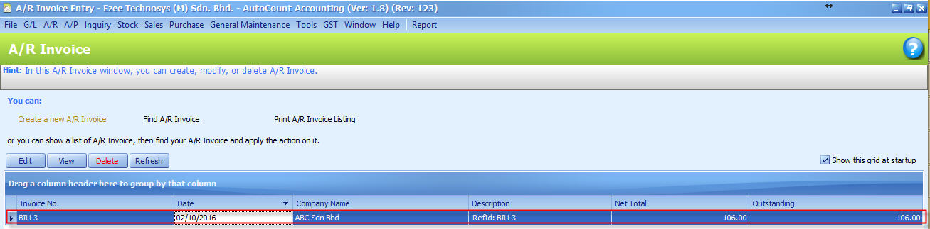
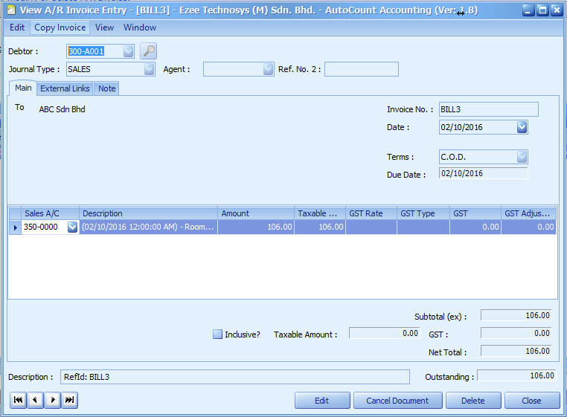
City ledger entry is posted as AR-Invoice into the Debtor ABC Sdn Bhd in Auto Count and outstanding value of invoice is 106

  - On 1st of November

Company ABC Sdn Bhd makes a payment of RM. 106 via Bank-in against bill no. BIL3 for Jackson Tay

At the eZee Frontdesk

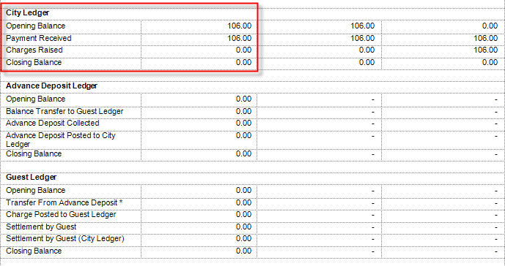
Opening Balance is 106, payment received is 106 which makes the closing balance 0

At eZee Autocount

Method 1: General Ledger
JV Receipt
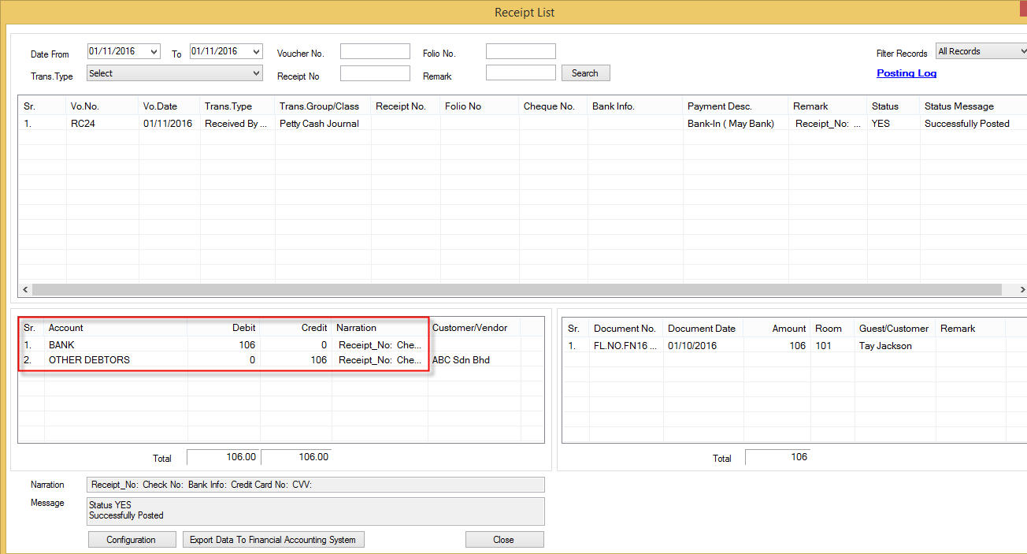
CR. OTHER DEBTORS 106
DR. BANK 106
It will credit the OTHER DEBTORS under the General Ledger

Method 2: AR Debtors
AR Receipt
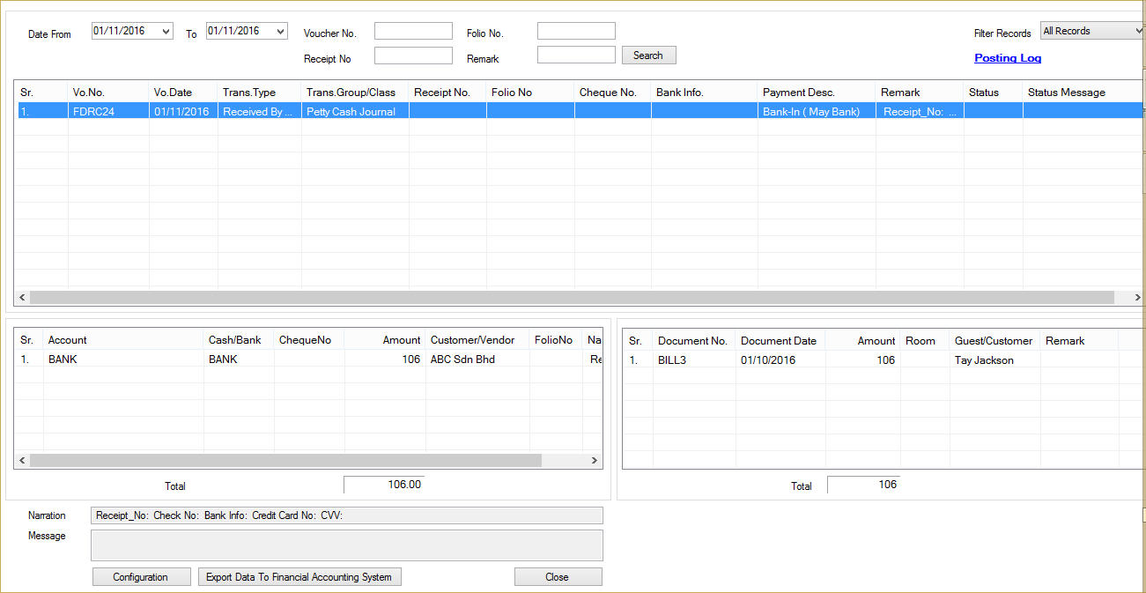

CR. ABC Sdn Bhd 106
DR. BANK 106
This will credit the debtors account ABC Sdn Bhd and knock off the earlier AR-Invoice BIL3

At AutoCount

Method 1: General Ledger
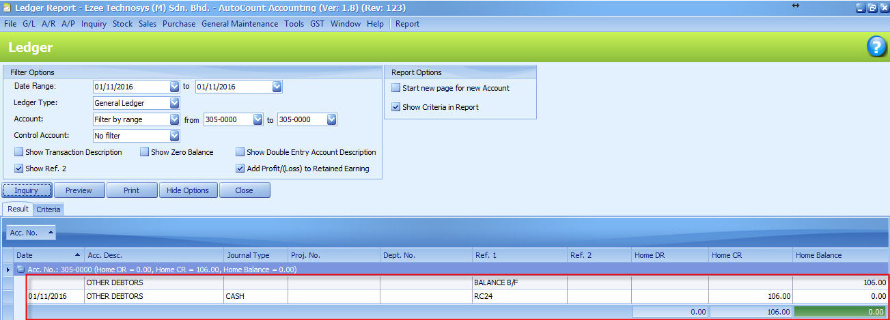

OTHER DETORS closing balance is 0 which is same as Daily Summary Report at the eZee Frontdesk

Method 2: AR Received Payment

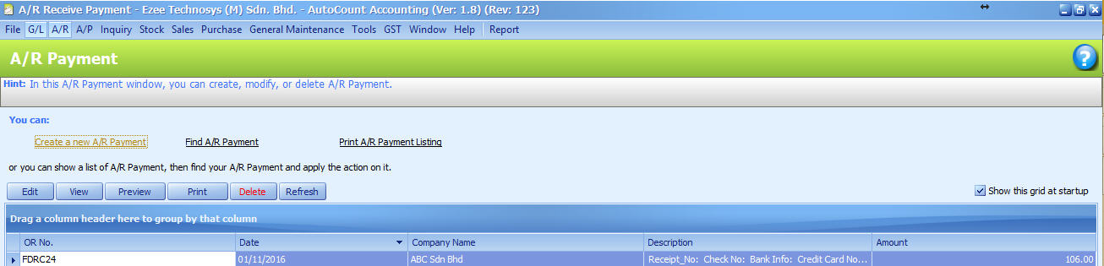
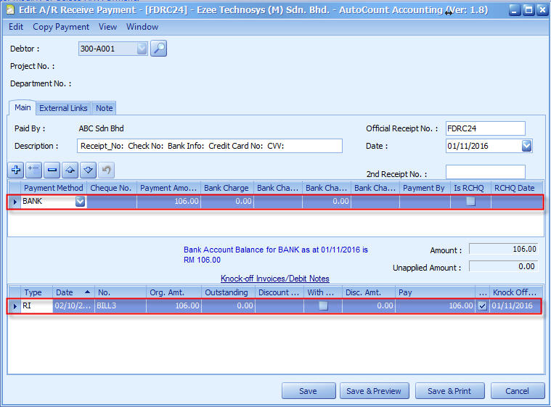
The receipt FDRC24 has knocked off BILL3 in AutoCount.

Choice for Method 1 and Method 2 differs with different client but you have to make sure that you use either one of the method otherwise it will create duplicate entries into the Guest Ledger.

In method 1 make sure that the closing balance of OTHER DEBTORS account in AutoCount is tallied with eZee Frontdesk

In Method 2 total of Outstanding AR amount and closing balance of City Ledger should tally.

